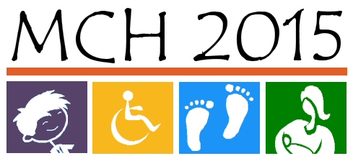
Maternal Child Health 2015
Needs Assessment
Panel of Experts – Session 2
SRS Learning Center, 2nd and MacVicar
8:30 a.m. – 4:30 p.m., January 29th, 2010
AGENDA

8:30 Check-In and Continental Breakfast (breakfast prepared by SRS Learning Center staff as a fundraiser for Project Topeka)
9:00 Welcome (Room A/B) Linda Kenney
9:10 Plenary Session: Review of Session 1 Results, Charge to Group for Session 2 Linda Kenney
9:40 Move to Workgroup Session Room, Introduce Expert Panelists
Mothers & Infants (Room C) Jean DeDonder, Facilitator
Children & Adolescents (Room A/B) Jon Anderson, Facilitator
Children & Youth with Special Health Care Needs (Room D) Donita Whitney-Bammerlin, Facilitator
10:00 Workgroup Session: Present Data (Built-in Break)
11:00 Workgroup Session: Identify Possible Priorities – Tool #3
11:45 Workgroup Session: Select Top 5 Priorities – Begin Tool #4
12:05 Break, Pick up Lunches (Room 2)
To avoid congestion in the lunch line, it is suggested that the three population work groups may wish to stagger their lunch pick-up times 5-10 minutes apart:
12:05 – 12:20 CYSCHN
12:10 – 12:25 Mothers and Infants
12:15 – 12:30 Children and Adolescents
12:30 Workgroup Session: Working Lunch and Finalize Top Priorities with Workgroup – Finish Tool #4
1:45 Workgroup Session: Formulate Action Steps for Each Priority – Tool #5
(Workgroups will break as needed)
3:15 Move to Room A/B for Closing Plenary Sessions
3:20 Plenary Session: Work Group Reports (10 minutes per group)
As Large Group, Note Cross-Cutting Issues and Complementary Action Steps
4:15 Plenary Session: Wrap-up and Door Prizes Linda Kenney

Website: www.datacounts.net/mch2015

